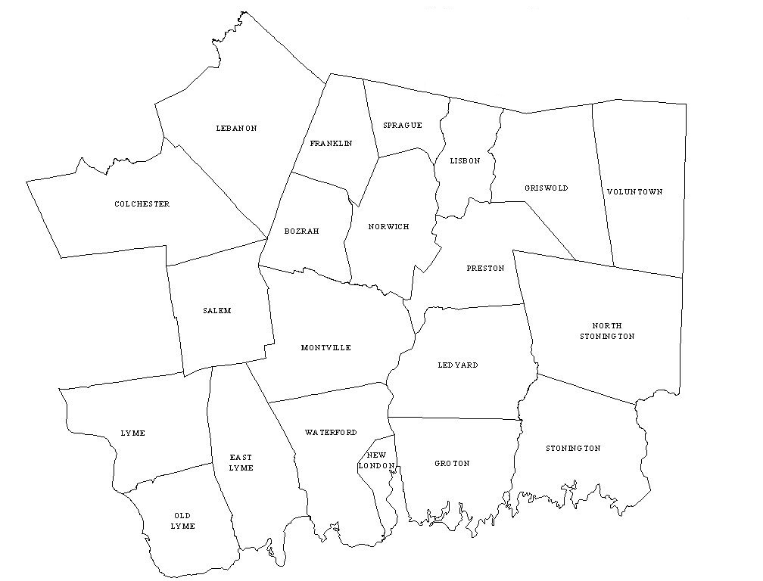

**SOUTHEASTERN CT BUILDING OFFICIALS (SECTBO)**

**BY-LAWS**

**EFFECTIVE: Feb. 20, 2016**

**Article I**

This organization shall be known as SECTBO.

The corporate office shall be located within the boundaries of New London County, Connecticut.

**Article II**

General Purpose:

Recognizing the need to promote continuing education to assist Municipal Code Officials in methods and procedures utilizing Building Codes and Regulations adopted and uniformity of enforcement procedures for public safety in construction, use, and occupancy of all types of structures:

Representatives of SECTBO have agreed to work together for the purposes hereinafter outlined.

1. To disseminate information and conduct monthly educational programs to enable the Municipal and other Building Officials to better interpret laws and to better perform their services as code officials in their respective localities.
2. To inform the code officials of new procedures of enforcement, new methods of construction, the use of new products or materials available to the building trades.
3. To act as a responsible authority on matters affecting code officials in general.
4. To encourage the use of modern updated building codes. Laws and regulations. Promote efficient adoption, administration and enforcement of uniform buildings, maintenance and fire protection codes and other related codes and standards, and promote programs or legislation of benefit to the public, which will develop increased levels of safety, health and welfare in buildings and other structures.

**Article III**

Membership

1. Active membership: Shall be composed of any licensed building official as defined by CGS §29-261 and who either is currently employed or has legal residency in New London County.
2. Associate Member: Shall be any building official that is not employed or has legal residency in New London County. Associate members shall not have voting rights.
3. If the eligibility of any Director of this organization ceases during their term in office due to death, disability, resignation or employment status, the membership at its next regular meeting shall name a successor from among its eligible candidates.

**Article IV**

Meetings, Quorum

1. The Board of directors shall meet at such time and such places as determined by the majority of the Board or upon call of the Chairman of the Board. At any meeting of the Board, a simple majority of the elected Board members shall constitute a quorum.
2. Notice of meetings: Each member of the Board shall receive notice of meetings not less than (10) days prior to the meeting unless so waived by a majority of the Board members.
3. Duties: The Board of directors shall propose new items of business and make recommendations at the regular meetings. Such business and recommendations shall be consistent with the purposes of the organization as outlined in Article II.
4. Funds: The Board shall authorize the depository of any funds of the organization and designate the Treasurer or other Board member to draw on such funds. The Board shall determine expenditures either within an approved budget or by resolution designating the officer or officers authorized to approve expenditures within specified limits. In the interim, between meetings of the Board, the Chairman and/or Vice Chairman shall approve ordinary expenses necessary to conduct the business of the organization, and furnish an accounting thereof to the Board for approval at the next regular meeting of the Board.
5. Dissolution: Upon a vote of the Directors to terminate the activities of District 7 the Directors shall:
   1. Settle all outstanding accounts.
   2. Perform and audit and render a written account to all Directors of Record.
   3. Disburse any remaining fund balance to all currently active members.
6. Conduct of meetings: Business conducted at all meetings of the Board shall follow Robert’s Rules of Order. The Chairman of the Board shall designate a Parliamentarian.
7. Officers: The Officers of this organization shall be Chairman, Vice Chairman, Secretary/Treasurer. The Board of Directors at the first meeting of the Board and annually thereafter shall elect the Officers.
8. Duties and Powers: The duties and powers of the officers shall be the duties normally prescribed to their respective offices. It shall be the responsibility of the Officers to plan, pursue and implement policies that will promote the purposes of the organization.
9. Succession: In the event of a vacancy in office, the Board will, by election, fill the vacancy for the unexpired term.
10. Terms of office: All officers shall be elected for a term of one year.
11. Committees: The board shall, from time to time, determine and establish the standing and special committees necessary to effectively carry out the program of the organization. The duties, responsibilities, limitations, and other directives to the committees shall be clearly stated in the resolutions establishing them. The Chairman shall appoint the members of all committees with the advice and consent of the Board.

ADOPTION AND AMENDMENTS

1. Effective date: This constitution and bylaws of this organization shall become effective upon their adoption by a majority of the Board of directors present and voting at a dully-called meeting.
2. Amendments: Amendments to the Constitution or bylaws, as adopted in accordance with the previous paragraph shall require an affirmative vote of 2/3’s of the Board of Directors present at any meeting provided at least (30) days notice shall be given to each Board member. All other amendments to rules and procedures shall require a simple majority vote of the Board of directors.